5 axis machining yields complex shapes in a single set up which is more efficient and productive than milling a part in a series of set ups. The elimination of multiple set up reduces cycle time and costs associated with preparing additional fixtures. Plus since the part remains in one set up from start to finish this eliminates alignment issues associated with multiple set ups. With 5 axis milling, complex parts that may otherwise have to be cast can be milled from a solid piece of material.

State of the art high speed milling machine, the machine can reach speeds up to 30m/min lower than requirement. (Datron)

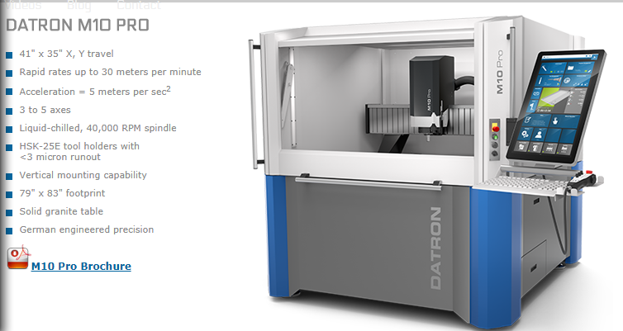

Machine size (Datron)

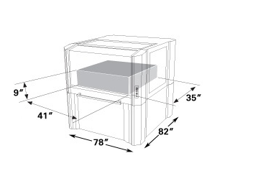

Integral part of my concept.

